NOISE POLLUTION MONITORING PHASE_4

PHASE_4 Development part 2

We know that a vibrating source alternately rises and drops the pressure of air particles with respect to atmospheric pressure. This variation in the pressure of the medium (air) above and below the atmospheric pressure is known as Sound Pressure.

The SI units of pressure are pascals (Pa) or Newton per meter square (N/m2). The human ear can detect sound pressures in the range of 20µPa all the way over 200Pa.

Two important points to note here. The range of sound pressure that can be produced is huge from 0.00002Pa to 1000Pa. The second point is the response of the human ear to an increase in sound pressure is not linear.

Hence, we measure sound using the decibel scale. Sound Pressure Level or SPL is the sound or noise measurement expressed as a logarithmic ratio of sound pressure to a reference sound pressure. This logarithmic ratio is the dimensionless unit of Power, the decibel (dB).

SPL = 20 log (p / pref) decibels (dB).

Here, ‘p’ is the root mean square value of the sound pressure in Pa (or N/m2). The reference sound pressure is 0.00002Pa or 2 × 10-5 N/m2.

A common way to represent sound pressure is dBA. This is a weighted Sound Pressure Level adjusted to the human sensitivity of the human ear.

The following table shows the relationship between Sound Pressure Level in dB and Sound Pressure in Pa.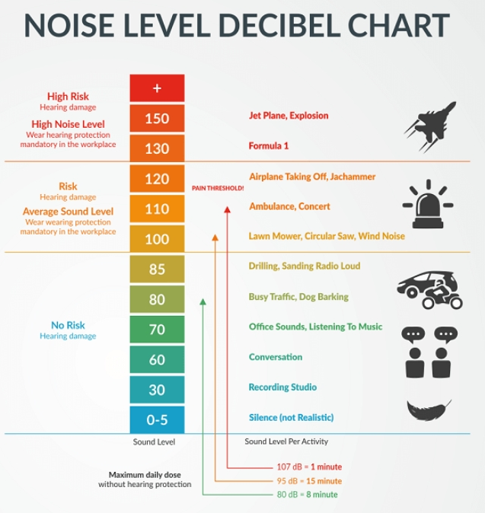

Bases on the above chart we have developed a noise pollution monitor using MIT app inventor

App 1:

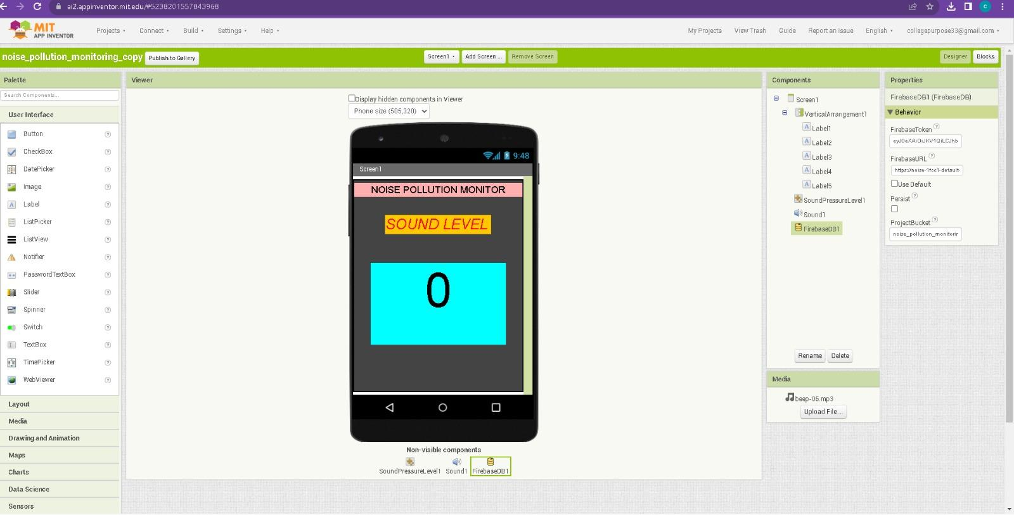

Shows realtime sound level

The block alignment:

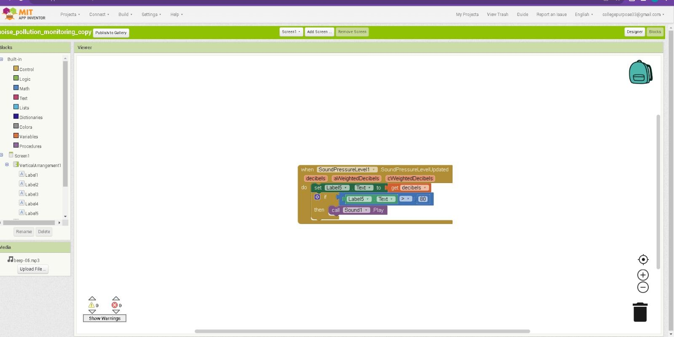

QR code to download :

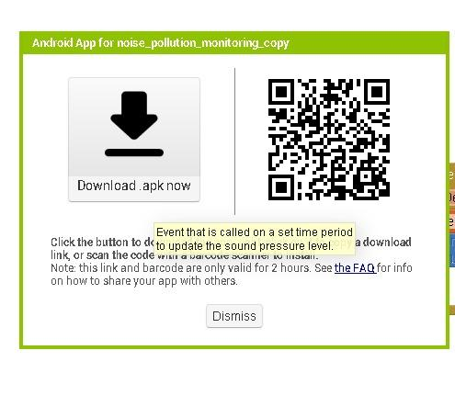

The output of building the app :

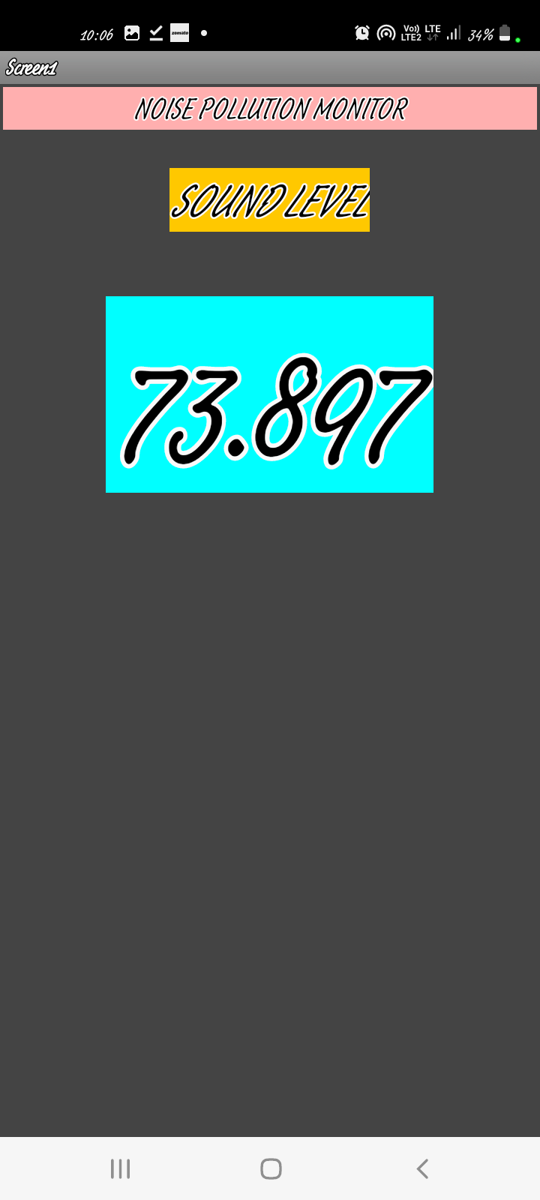

App 2:

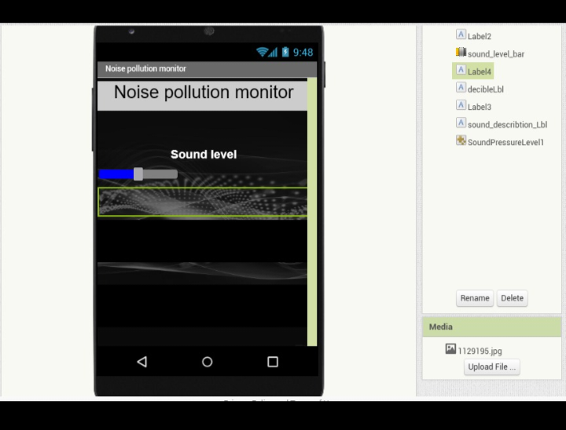

Shows realtime sound level and warns the reciever :

The block alignment :

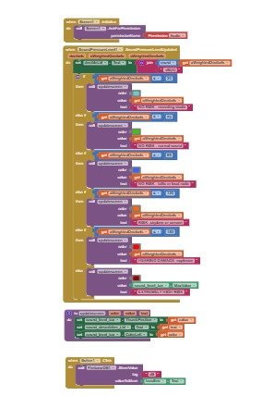

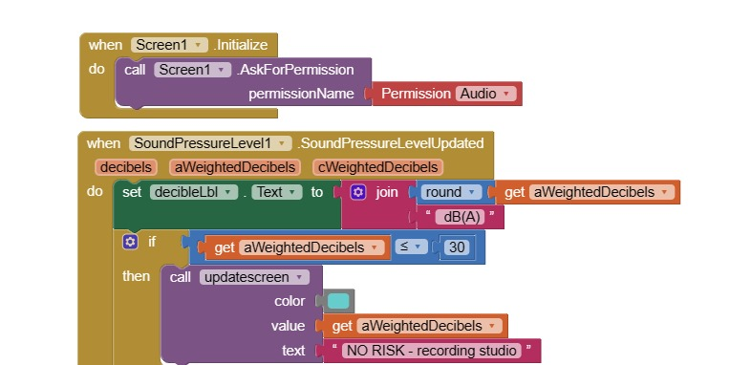

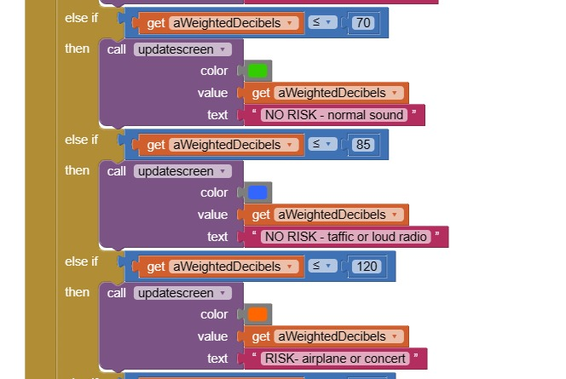

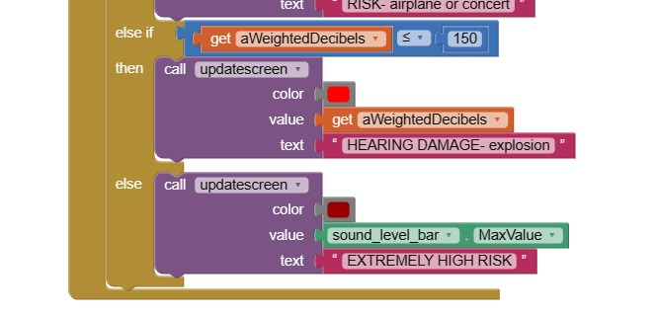

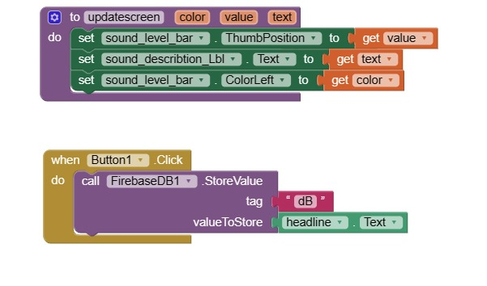

QR code to download the app

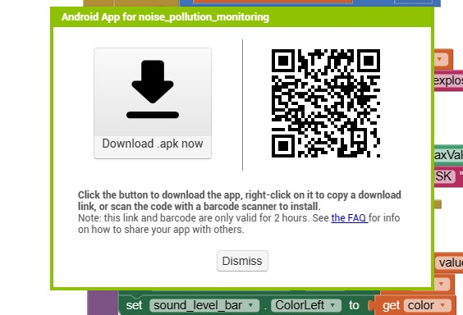

The output of building the app :

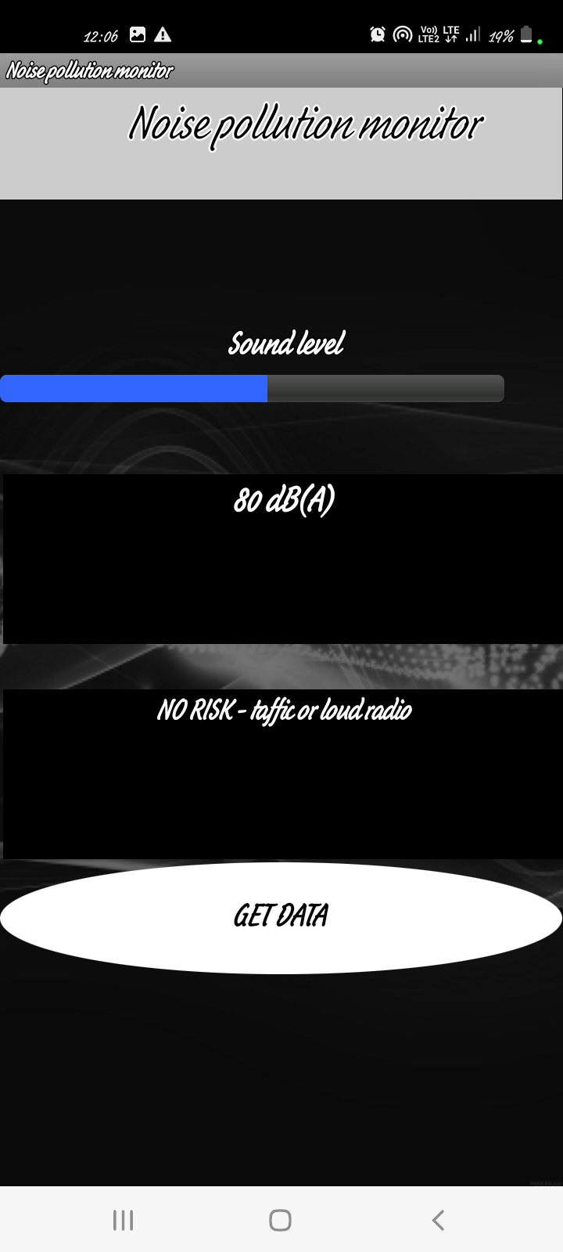

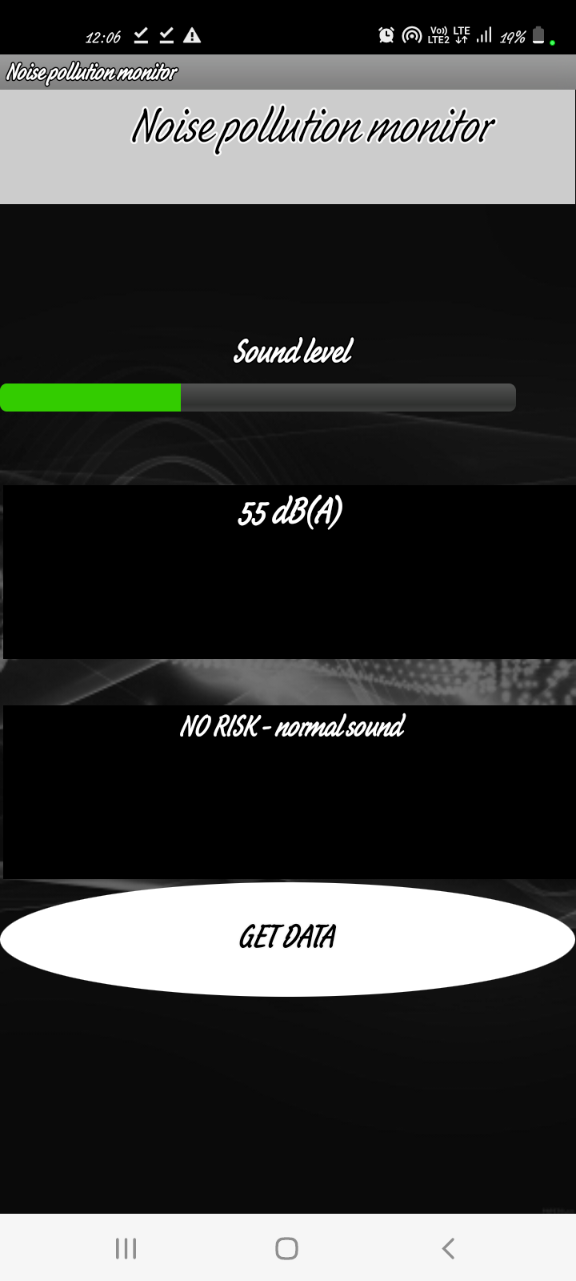

Development of noise pollution monitor in blynk:

Mobile view

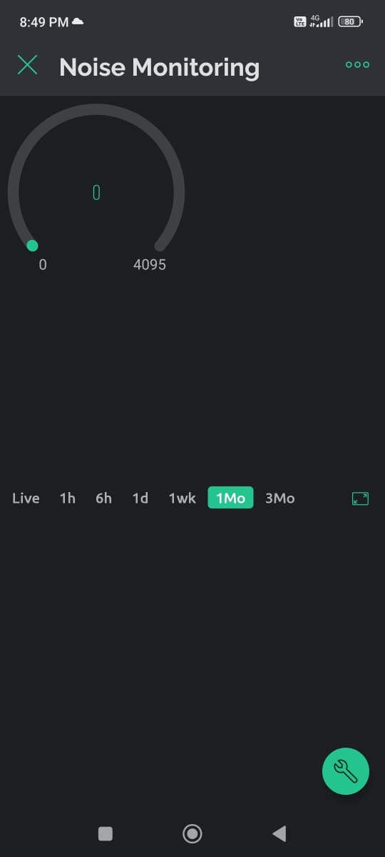

Desktop view

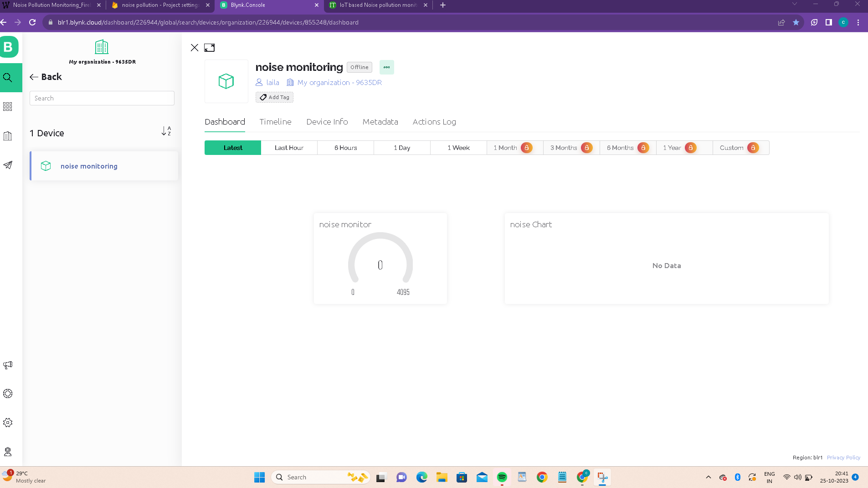

Autotoken for blynk console

OOmO9Am7t0y4SArifXeJSVF_2PlwWxDw